Wendy Shaw

222 words

**Berk, Nurullah (1906-1982)**

Nurullah Berk was an artist and writer in the Republic of Turkey. Berk first studied abroad in Paris with Ernest Laurent at the Ecole des Beaux Arts between 1924 and 1928. Upon his return to Turkey, he became a member of the recently established Society of Independent Painters and Sculptors. He spent a year in Paris studying with Andre Lhote and Fernand Leger, whose Cubist modernism reflected the ideas of Henri Bergson as developed by the Puteaux Group before World War I. Returning to Turkey in 1933, he became one of the founders of the d Group, a society of artists established in 1933 that promoted independent thought and modernist ideals. He also participated in the state-sponsored Homeland Tours project that sent artists to the provinces between 1938 and 1943. Berk promoted the expression of Turkish aesthetic ideals through a vocabulary of abstraction that combined flat abstraction with pattern drawn from the popular and folk traditions of Turkey. His *Woman Ironing* (1950) exemplifies his combination of Cubist abstraction with national identity in its idealization of the hard-working figure of the Turkish peasant woman with pattern derived from traditional Turkish flatwoven carpets.

**References and further reading**:

Berk, Nurullah. *Sanat Konuşmaları.* Istanbul: AB Neşriyatı, 1943.

Berk, Nurullah. *Türkiye’de Resim.* İstanbul: Güzel Sanatlar Akademisi Neşriyatı, 1943.

Tansuğ, Sezer. *Çağdaş Türk Sanatı.* Istanbul: Remzi Kitabevi, 1986.

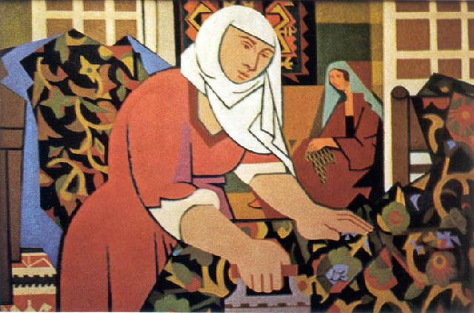

Nurullah Berk. *Woman Ironing*. 1950. Oil on canvas, 60 x 91.5 cm. Mimar Sinan Güzel Sanatlar Üniversitesi (MSGSÜ) Istanbul Museum of Painting and Sculpture.